Selenium Webdriver with Python
Objective: To be able to proceed with automation techniques using Selenium by Python
Tools:
- Python 3.10.0
- Selenium 4.47.0
Concepts Used:
- Installing Selenium
- Using Different Locators
- Drop-Down
- Navigating to Webpage
- Upload and download
- Error Handling
- Pop-ups and alerts
- Frames
SELENIUM INSTALLED
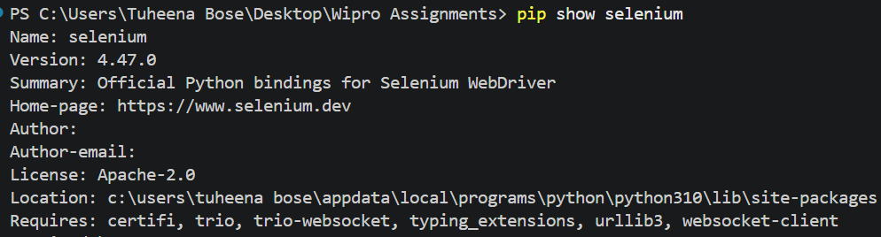
ERROR HANDLING
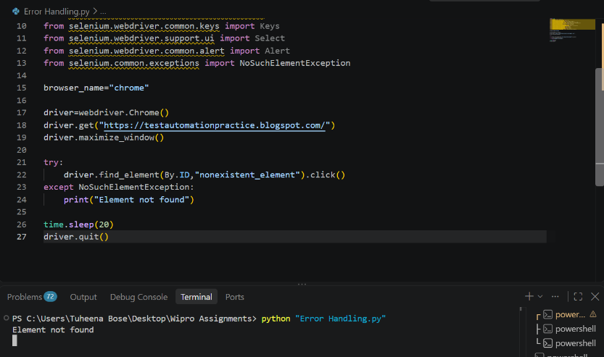

LOCATORS
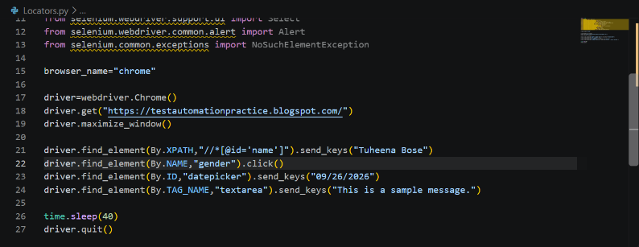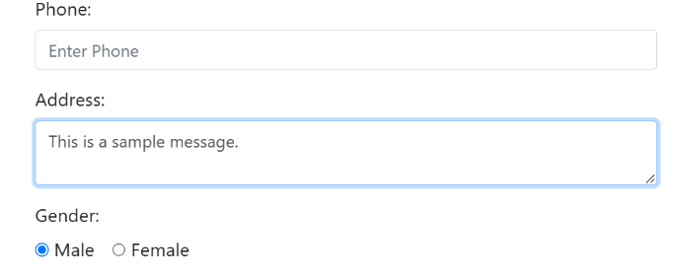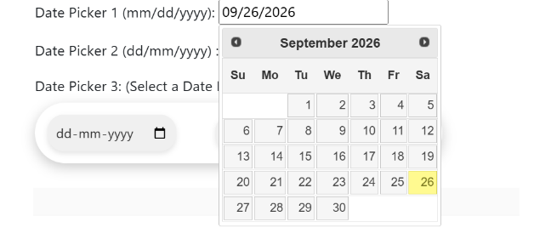

DROP DOWN
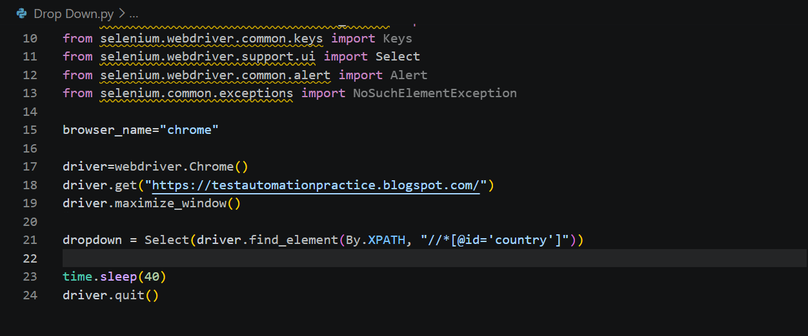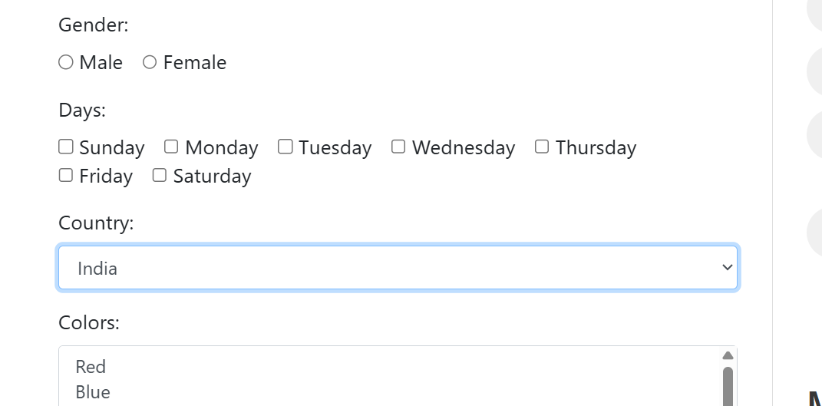
NAVIGATION
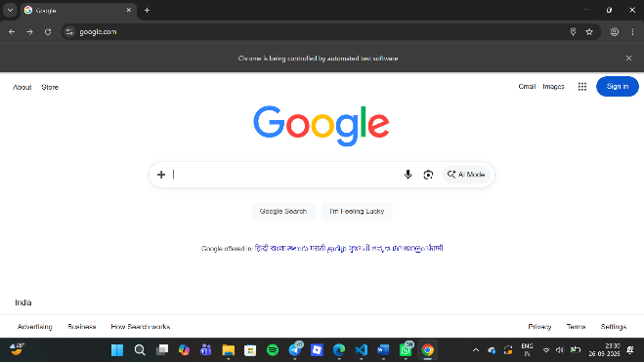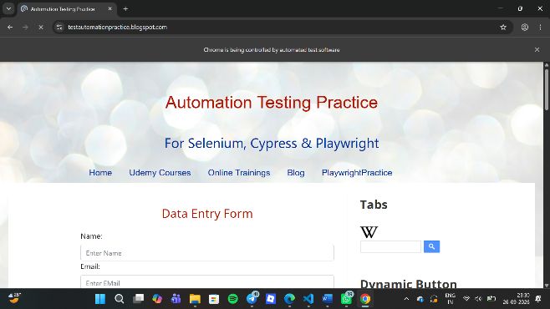
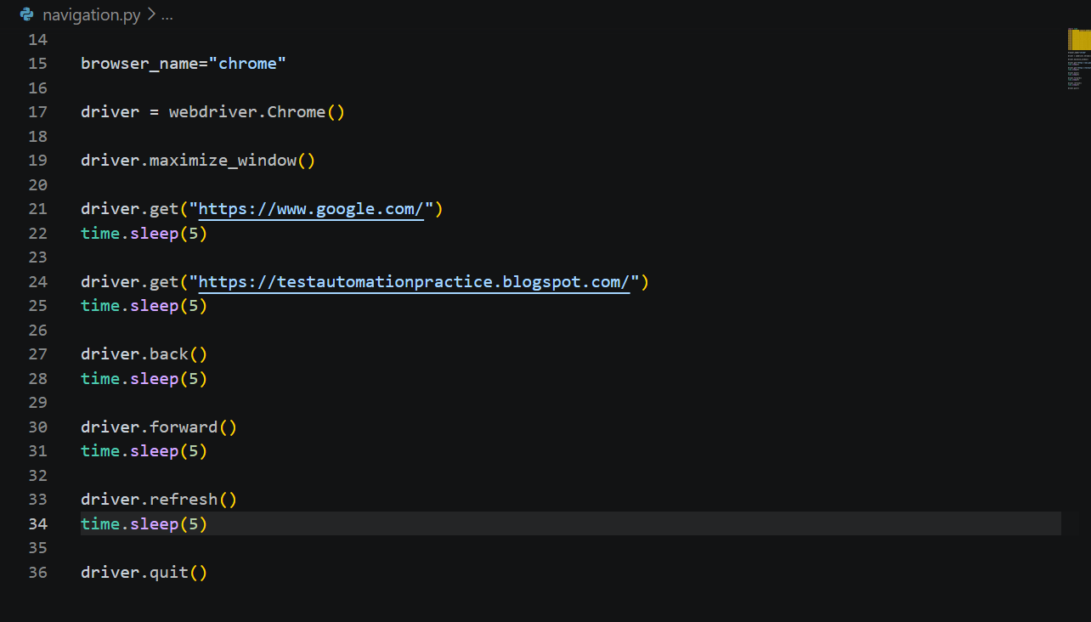
UPLOAD
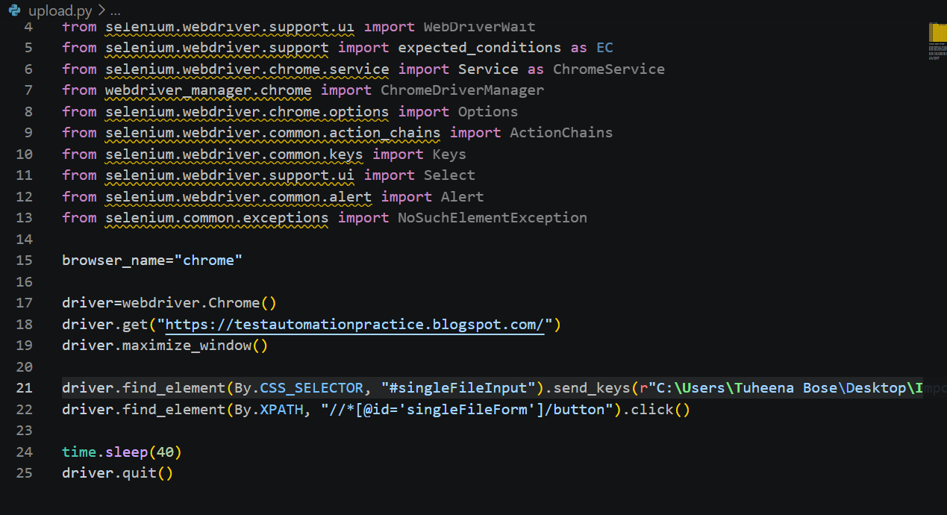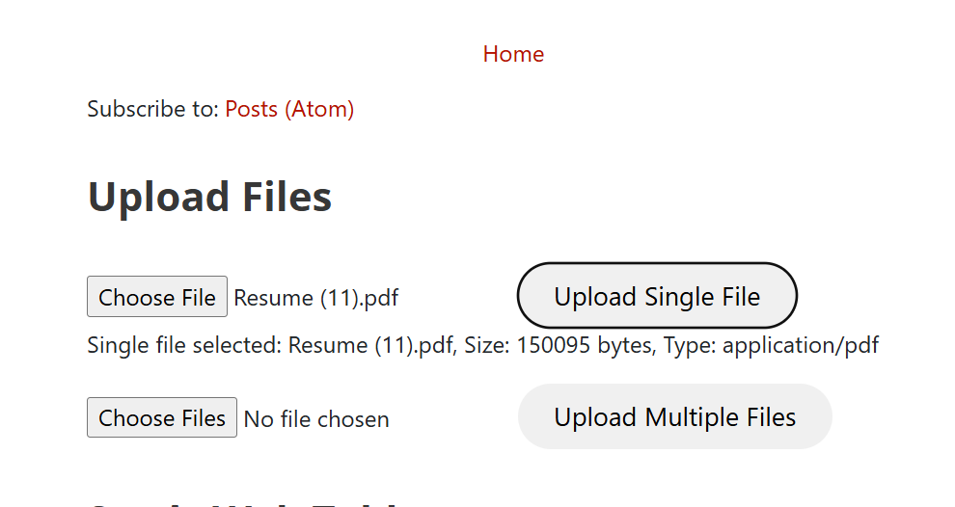
FRAMES
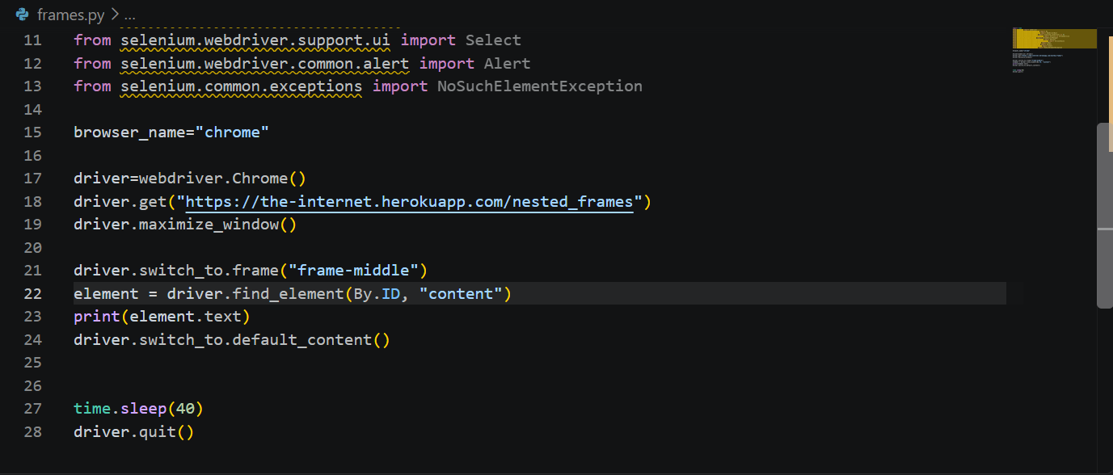
POPUPS AND ALERTS
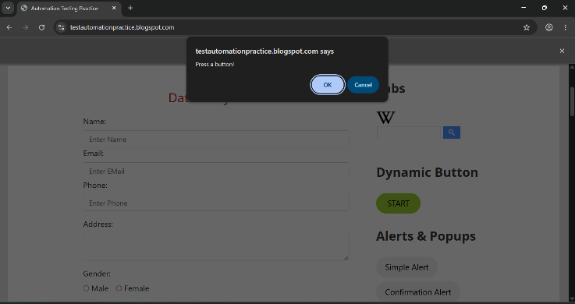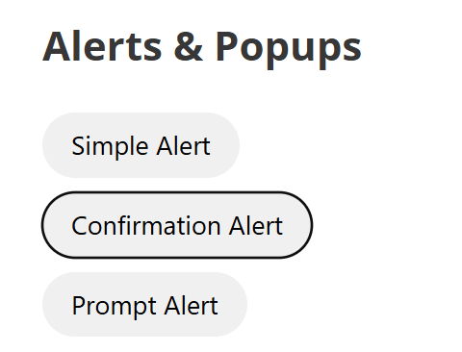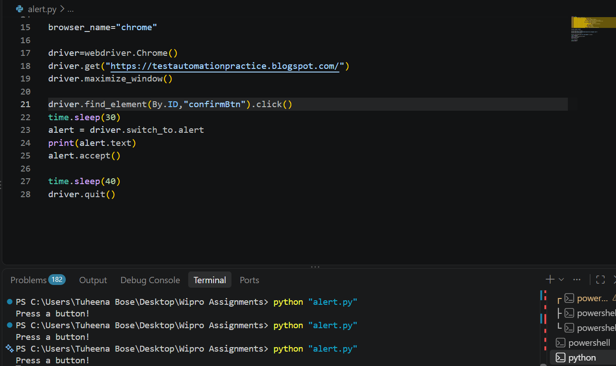

Conclusion
This module led to the progression of understanding the easier aspects of learning automation by python using selenium.

